**CSE103L Circuits & Systems-I Lab**

**Circuits And System 1**

**LAB REPORT # 10**



2020

**Submitted to:**

**Engr. Faiz Ullah**

**Submitted by:**

**TAYYABA**

**Registration No:**

**19PWCSE1854**

**Semester: 2nd**

**Class Section: C**

“On my honour, as student of University of Engineering and Technology,

I have neither given nor received unauthorized assistance

on this academic work.”

Student Signature: ______________

Sunday, August 9, 2020

**Department of Computer Systems Engineering**

**University of Engineering and Technology, Peshawar**

# ASSESSMENT RUBRICS LAB # 14

**Analyzing RC-Circuit using PSpice**

|  |  |  |
| --- | --- | --- |
| **Criteria** | **Excellent** | **Marks**  **Obtained** |
| **1. Objectives of Lab** | All objectives of lab are properly covered [Marks 0.5] |  |
| **2. RC-Circuit** | Brief introduction of RC-Circuit [Marks 1] |  |
| **3. PSpice** | Brief introduction about PSpice [Marks 0.5] |  |
| **4. Circuit Diagram** | Circuit diagram of RC circuit with proper labeling  [Marks 1] |  |
| **5. Procedure of PSpice, Graph** | PSpice procedure and steps followed for RC- Circuit settings and to get graph. Simulated graph results are also shown  [Marks 6] |  |
| **6. Conclusion** | Conclusion about RC-Circuit analysis [Marks 1] |  |

**Experiment # 14**

## **Analyzing First RC Transient Circuit**

# Objectives:-

In this we will analyze first RC circuit using PSPICE software.

# Apparatus:-

A computer with PSPICE installed on it

# RC-Circuit:-

A resistor–capacitor circuit, or RC filter or RC network, is an electric circuit composed of resistors and capacitors driven by a voltage or current source. A first order RC circuit is composed of one resistor and one capacitor and is the simplest type of RC circuit.

# PSPICE Simulator:-

**PSPICE** is a computer-aided simulation program that enables you to design a circuit and then simulate the design on a computer. As this is one of its main purposes, it is used extensively by electronic design engineers for building a circuit and then testing out how that circuit will simulate. There are a lot of things we can do with **PSPICE**, but the most important things for you to learn are

1. Design and draw circuits.
2. Simulate circuits.
3. Analyze simulation results.

**Circuit Diagram:**

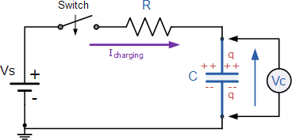

**Procedure for Circuit 1:-**

* 1. Open schematic program of PSPICE.
  2. Click on the “Get New Part” button on the toolbar.
  3. Type ‘r’ in the search bar and place the resistors on the white sheet and assign value **100Ω**.
  4. Type ‘vdc’ in the search bar and place it on the white sheet and assign value **10V**.
  5. Type ‘c’ in the search bar for capacitor and place it on the white sheet and assign value of **1n**.
  6. Type ‘switch’ in the search bar for switch **(tclose=0)** and place it on the white sheet.
  7. Type ‘gnd-earth’ and place it on the white sheet.
  8. Now arrange these components on the white sheet according to the circuit diagram as following.

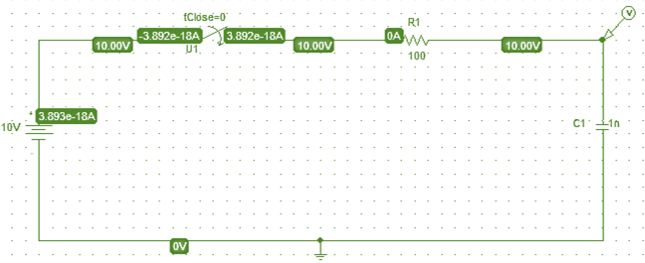

Figure 14.1 RC Circuit Diagram

* 1. Click voltage/level Marker button and place on the specified position in the circuit.
  2. Now click Setup Analysis button.
  3. A window will open check the transient box and then click on the transient button.
  4. Set the Print step and final time to a suitable values.
  5. Check the ‘skip initial transient solution’ box and click on ok.
  6. Now simulate the circuit by clicking the simulate button.

**Graph:-**

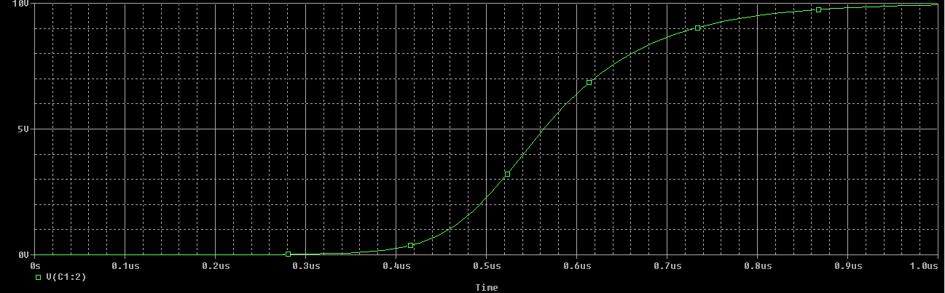

**Procedure for Circuit 2:-**

1. Open schematic program of PSPICE.
2. Click on the “Get New Part” button on the toolbar.
3. Type ‘r’ in the search bar and place the resistors on the white sheet and assign value **10Ω**.
4. Type ‘vdc’ in the search bar and place it on the white sheet and assign value **15V**.
5. Type ‘c’ in the search bar for capacitor and place it on the white sheet and assign value of **1n**.
6. Type ‘switch’ in the search bar for switch **(tclose=0)** and place it on the white sheet.
7. Type ‘gnd-earth’ and place it on the white sheet.
8. Now arrange these components on the white sheet according to the circuit diagram as following.

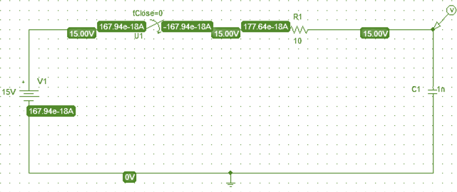

Figure 14.2 RC Circuit Diagram

1. Click voltage/level Marker button and place on the specified position in the circuit.
2. Now click Setup Analysis button.
3. A window will open check the transient box and then click on the transient button.
4. Set the Print step and final time to a suitable values.
5. Check the ‘skip initial transient solution’ box and click on ok.
6. Now simulate the circuit by clicking the simulate button.

# Graph:

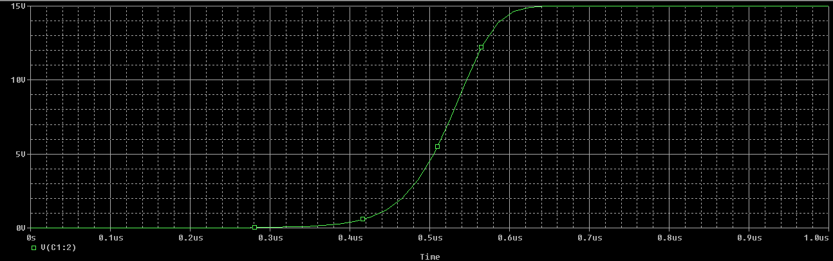

**Procedure for Circuit 3:-**

1. Open schematic program of PSPICE.
2. Click on the “Get New Part” button on the toolbar.
3. Type ‘r’ in the search bar and place the resistors on the white sheet and assign value **90Ω**.
4. Type ‘vdc’ in the search bar and place it on the white sheet and assign value **25V**.
5. Type ‘c’ in the search bar for capacitor and place it on the white sheet and assign value of **1n**.
6. Type ‘switch’ in the search bar for switch **(tclose=0)** and place it on the white sheet.
7. Type ‘gnd-earth’ and place it on the white sheet.
8. Now arrange these components on the white sheet according to the circuit diagram as following.

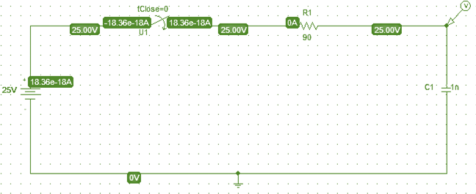

Figure 14.3 RC Circuit Diagram

1. Click voltage/level Marker button and place on the specified position in the circuit.
2. Now click Setup Analysis button.
3. A window will open check the transient box and then click on the transient button.
4. Set the Print step and final time to a suitable values.
5. Check the ‘skip initial transient solution’ box and click on ok.
6. Now simulate the circuit by clicking the simulate button.

# Graph:

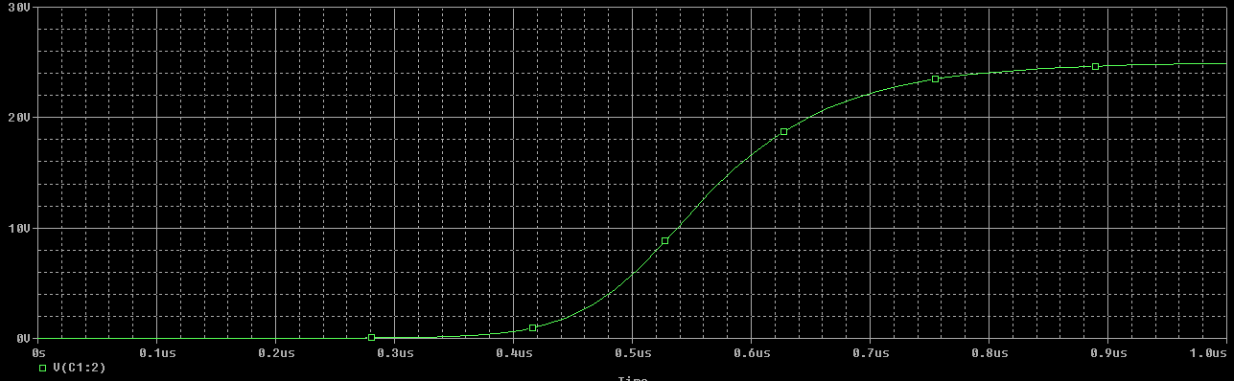

**Procedure for Circuit 4:-**

1. Open schematic program of PSPICE.
2. Click on the “Get New Part” button on the toolbar.
3. Type ‘r’ in the search bar and place the resistors on the white sheet and assign value **50Ω**.
4. Type ‘vdc’ in the search bar and place it on the white sheet and assign value **2V**.
5. Type ‘c’ in the search bar for capacitor and place it on the white sheet and assign value of **1n**.
6. Type ‘switch’ in the search bar for switch **(tclose=0)** and place it on the white sheet.
7. Type ‘gnd-earth’ and place it on the white sheet.
8. Now arrange these components on the white sheet according to the circuit diagram as following.

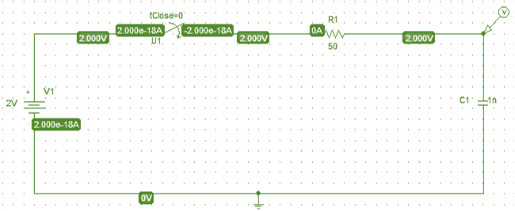

Figure 14.4 RC Circuit Diagram

1. Click voltage/level Marker button and place on the specified position in the circuit.
2. Now click Setup Analysis button.
3. A window will open check the transient box and then click on the transient button.
4. Set the Print step and final time to a suitable values.
5. Check the ‘skip initial transient solution’ box and click on ok.
6. Now simulate the circuit by clicking the simulate button.

# Graph:

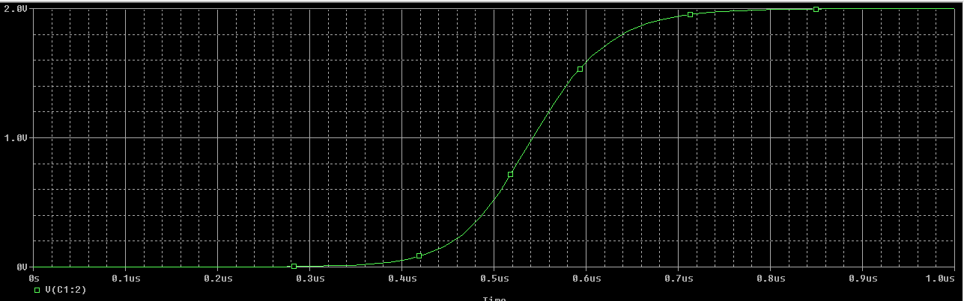

**Procedure for Circuit 5:-**

1. Open schematic program of PSPICE.
2. Click on the “Get New Part” button on the toolbar.
3. Type ‘r’ in the search bar and place the resistors on the white sheet and assign value **15Ω**.
4. Type ‘vdc’ in the search bar and place it on the white sheet and assign value **200V**.
5. Type ‘c’ in the search bar for capacitor and place it on the white sheet and assign value of **1n**.
6. Type ‘switch’ in the search bar for switch **(tclose=0)** and place it on the white sheet.
7. Type ‘gnd-earth’ and place it on the white sheet.
8. Now arrange these components on the white sheet according to the circuit diagram as following.

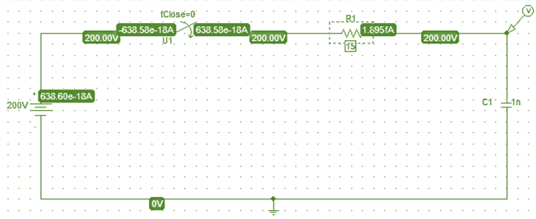

Figure 14.5 RC Circuit Diagram

1. Click voltage/level Marker button and place on the specified position in the circuit.
2. Now click Setup Analysis button.
3. A window will open check the transient box and then click on the transient button.
4. Set the Print step and final time to a suitable values.
5. Check the ‘skip initial transient solution’ box and click on ok.
6. Now simulate the circuit by clicking the simulate button.

# Graph:

**Conclusion:-**

After creating different circuit we analyze that capacitor stores charge and when it get completely charged the current across resistor becomes zero.